**User Interface Design**

**Version 2.1**

**Project Management App**

**Team A**

**CSC-354**

**Fall 2015**

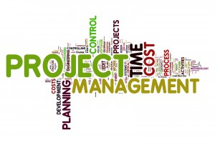

11/23/2015

Author: Hector Richeiz and Tyler Mariano

Submitted To: Dr. Joo Tan

**TABLE OF CONTENTS**

Revision History…………………………………………………………………………………..ii

1.0 Introduction……..….....…………………………….…...…………………………….……....1

1.1 What is High Fidelity?...................................................................................................1

1.2 Purpose..……………………………….………………………………………………1

2.0 Screen Flow Diagram…………………………………………………………………………2

3.0 Wireframes………………………………………………………………………………….…3

3.1 Initial Icon………...………...………………………………………………………...3

3.2 Splash Screen……………....…………………………………………………………4

3.3 Create Account Screen...……………….……………………………………………..5

3.4 Login Screen………………………………………………………...……………......6

3.5 Tutorial Screen…….……………………………………………...…………………..7

3.6 Main Menu Screen...………………………………………………………………….8

3.7 Create Project Screen..………………………………………………………………..9

3.8 Project Screen...…………………………………………………………………….10

3.9 Profile Screen……………………………………………………………………….11

3.10 Member’s View Screen….…………….……………………………………………12

3.11 Leader’s View Screen……..…………………...…………………………………...13

3.12 Progress Screen……...……………………………………………………………...14

3.13 Calendar Screen…...………………………………………………………………..15

3.14 Task List Screen..…………….…………………………………………………….16

3.15 Message Screen………………...…………………………………………………...17

3.16 Member List Screen………………….……………………………………………..18

**REVISION HISTORY**

|  |  |  |  |
| --- | --- | --- | --- |
| Version | Author | Description | Date |
| 1.0 | Hector Richiez | I created the frame that will be used for UID | 11/08/2015 |
| 1.1 | Tyler Mariano | I created the screen flow diagram and added all fifteen screen wireframe diagrams to the document. | 11/11/2015 |
| 1.2 | Hector Richiez | Added the paragraphs for the different screens explanation. | 11/12/2015 |
| 1.3 | Tyler Mariano | I redid the text styling and format of the document as well as changing headers and table of contents sections. | 11/12/2015 |
| 1.4 | Jennifer Li | I added the paragraph for the wireframe section. | 11/13/2015 |
| 2.0 | Hector Richiez | Updated all paragraphs with contents that give a better explanation of screens flow. I as well corrected some grammar error. | 11/19/2015 |
| 2.1 | Jennifer Li | Fixed the page numbers, grammatical changes, and placement of images. | 11/20/15 |

**1.0 INTRODUCTION**

This document presents the graphical interface of the Project Management App by using first, a screen flow diagram that shows the user the flow of interaction between the user and the App. Second, it presents to the user the different screens of the app, in a high fidelity prototypes to give the user a look and feel of the final screens interface of the project Management App.

**1.1 What is High Fidelity?**

High fidelity prototypes offers a rich graphical representation of the user interface of an application. It usually resembles and behaves as the final product. It differentiate from low fidelity, which is a simple mockup sketch of the targeted product usually done by hand drawing, in that the sketches in high fidelity are closed in appearance to the final product and are designed using sophisticated designing software. High fidelity prototypes was chosen as the tool to present to the user the various screens of the Project Management App.

**1.2 Purpose**

The purpose of this document is to give the end user an idea of the flow of information when interacting with the Project Management App and an idea of the look and feel of the final product upon delivery. It also assists the users to familiarize with the 16 different screens that the final product will have to give its users a comfortable experience through it’s simple but robust GUI interface.

**2.0 SCREEN FLOW DIAGRAM**

The screen flow diagram shows in a hierarchical way the flow of interaction that the user and the system could maintain as the user navigate through the application’s GUI to accomplish a desired task. The first screen presented to the user, is the icon screen which the user can click to run the app. The next screen the user sees is the splash screen which is a transitional screen that will take the user to the login screen or the create account screen if the app detects that it is a new user. If the user is redirected to the create an account screen, he or she will be able to create an account.

Once an account has been created, the user will be redirected to the tutorial screen which is the main source to learn how to operate the app. From the tutorial screen the user will have a button that will allow the user to go to the login screen. From the login screen, the user can go to the main menu screen which is the screen where all the action starts since the user will be able to create one project or multiple projects by clicking the “+” sign located at the top left corner of the screen. The projects in the menu screen are hyperlinks that once clicked will take the leader to the leader’s view screen or the members to the member’s view screen. From these two screens they will be able to navigate to any other screen in the app depending on the user’s privilege.

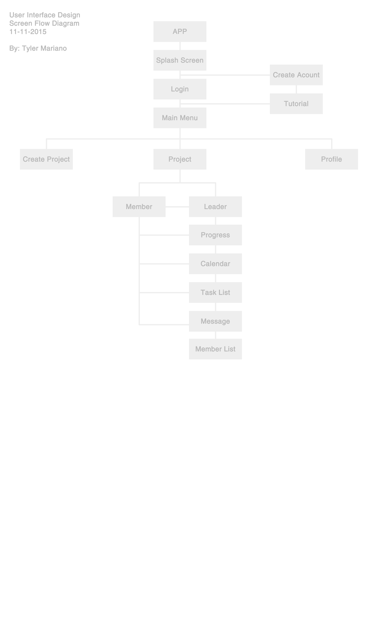

**3.0 WIREFRAMES**

A wireframe is a basic visual representation of content layout in an application design. The wireframe will act as a prototype that specifies the placement of features, such as the logo, header, footer, content, and navigation.

**3.1 Initial Icon**

The initial pictogram of the App represents the icon the user will see on their devices. Clicking the Icon will start running the application.



**3.2 Splash Screen**

The splash screen is the transition screen which will present the user with the logo of the Project Management App, as well as the date created and the current version and then will transition to the create account screen if it is a new user or to the login screen if it is a user with a register account.

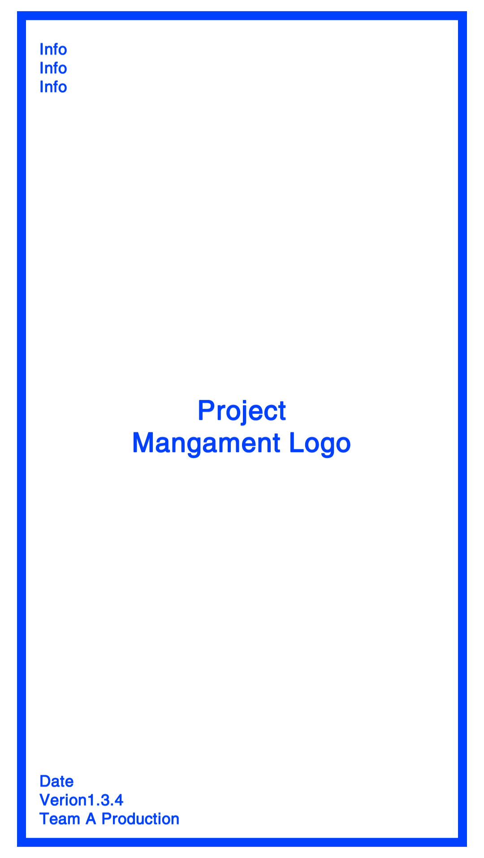

**3.3 Create Account Screen**

The create account screen is the one that starts the interaction between the user and the app. The user gets to this screen from the splash screen. it asks the user to create an account so he or she can start using the application. To create an account the user will have to provide the system with a user name and a password. There are 3 textboxes that will need to be filled out before an account could successfully be created. After successfully creating an account, the user will be directed to the tutorial screen where the user can start learning how to navigate the app.

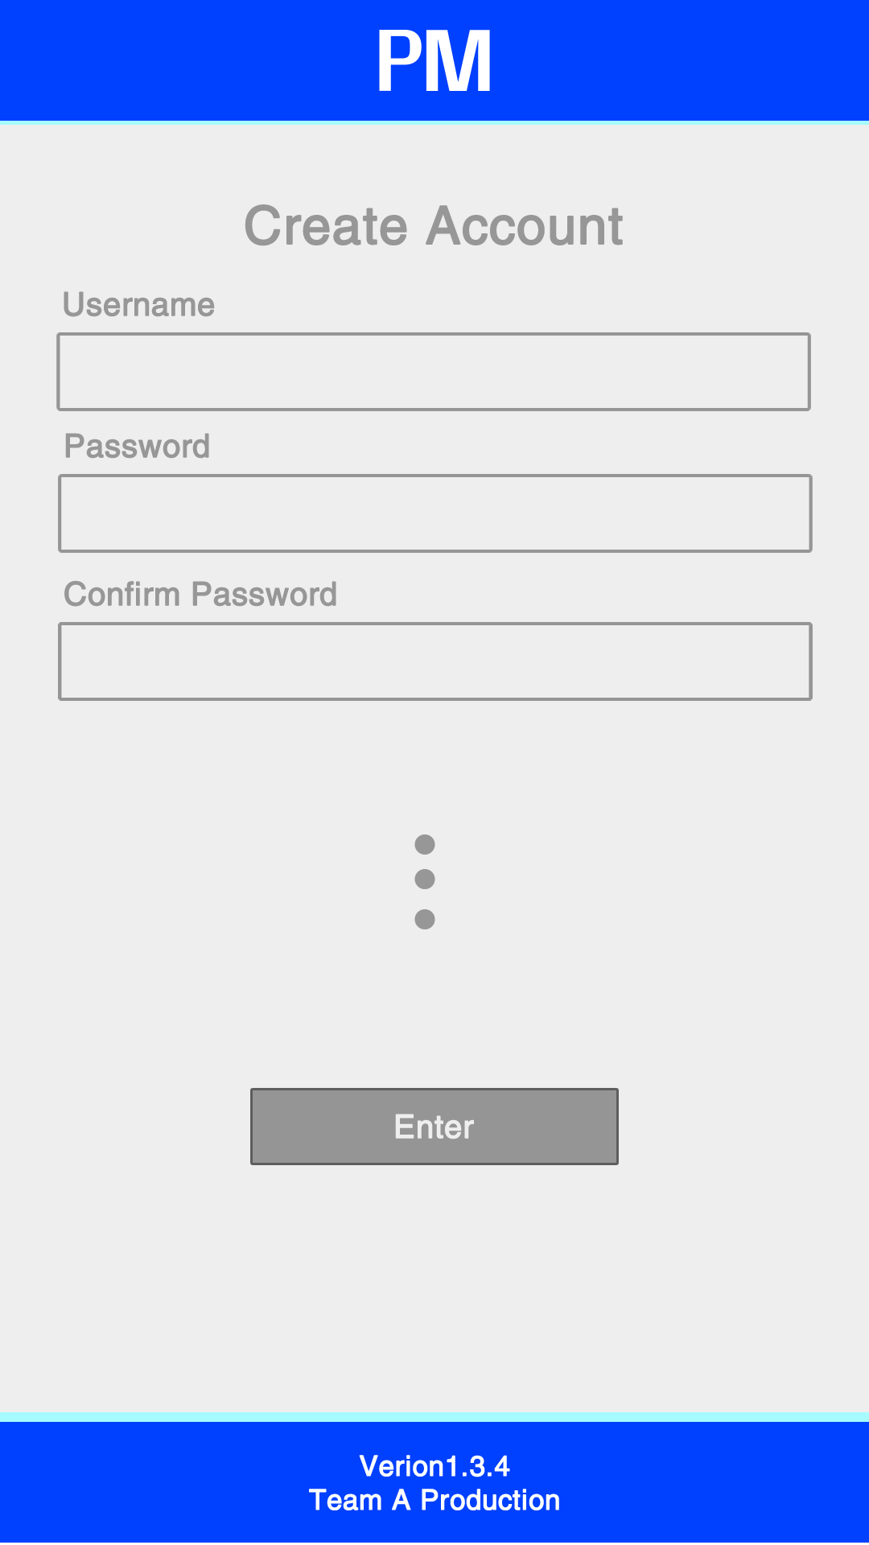

**3.4 Login Screen**

The login screen asks the user for a user password and a username. When both textboxes are filled with the required information, the login button will be available for the user to click and login to the app.

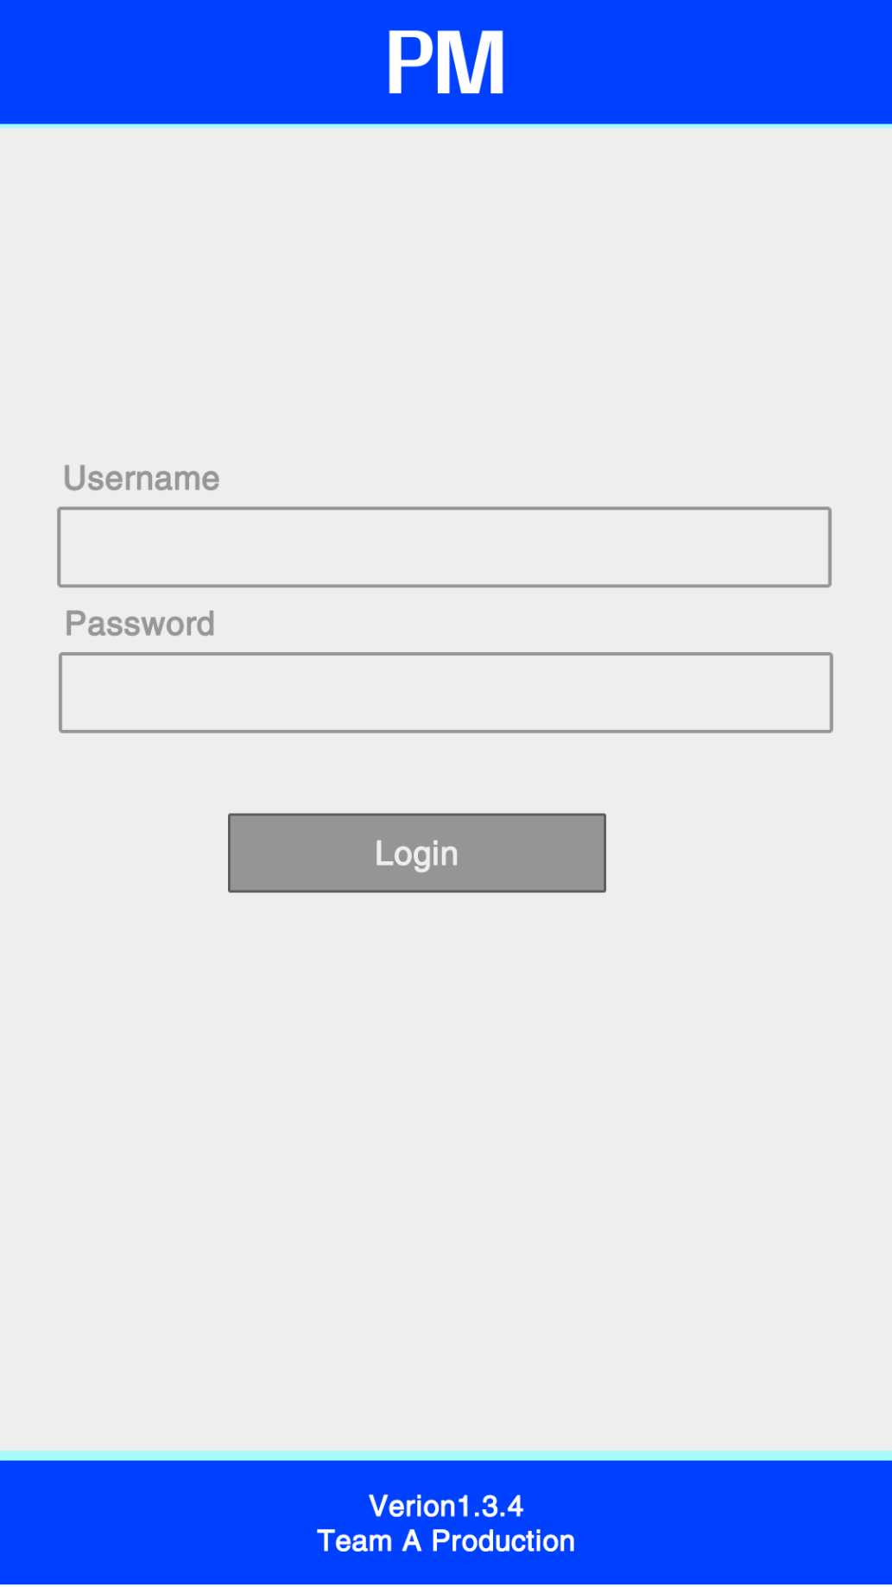

**3.5 Tutorial Screen**

The tutorial screen serves as a learning resource that the application users have to their advantage to learn how to navigate through the app, learn shortcuts, use efficiently the services provided by the application and how to start a project, add members, assign task, upload completed task and view tasks and project progress. The user gets redirected to this screen when the user creates an account. It can also be accessed from the main menu screen.

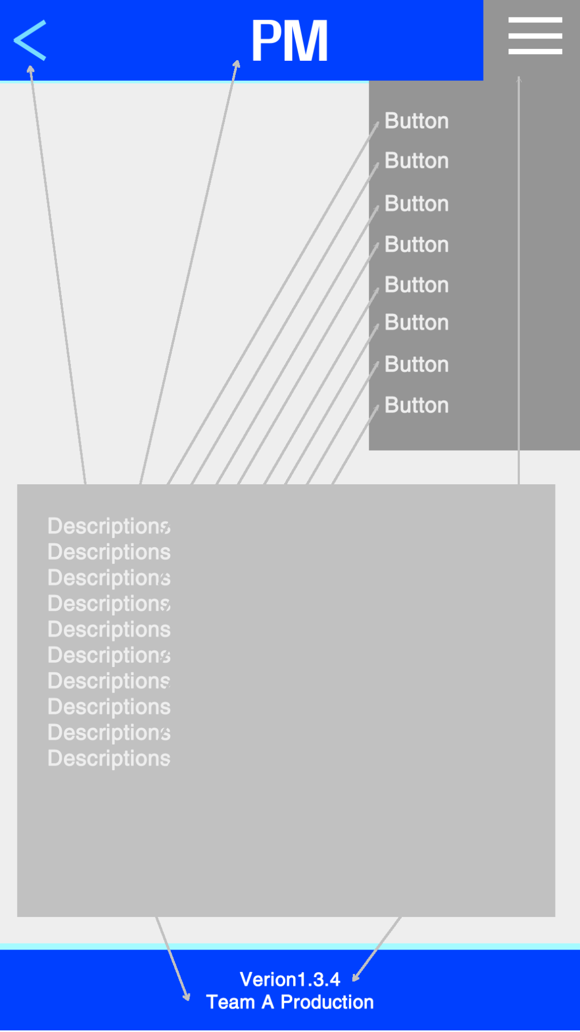

**3.6 Main Menu Screen**

The main menu screen is the screen the users will see once a user has logged in to the app. In this screen the user will be able to create a project or multiple projects; by clicking the plus sign situated in the upper left corner of the screen. It will take the user to the create project screen where the user will be able to enter the properties or values needed to create a project.

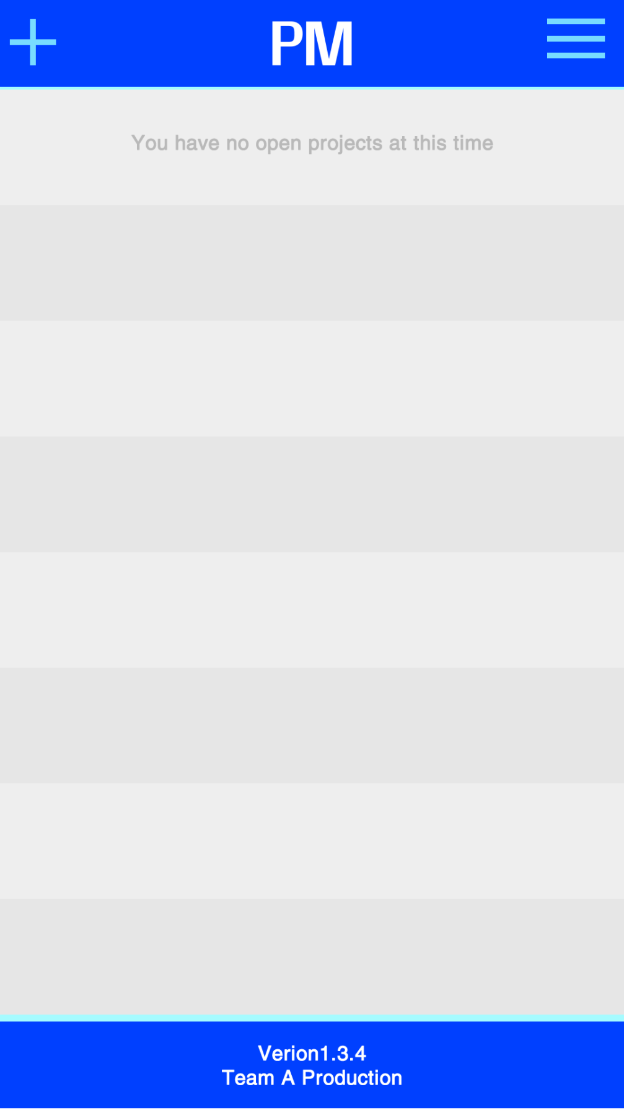

**3.7 Create Project Screen**

The create project screen is where the user can enter the requested information to create a project. To create a project the leader of the project will have to provide the system with a project name, description, goal and estimated cost. All the fields in this screen are required to create a project. Any omission of any of the required information will result in an error asking the user to fill out each and every text field.

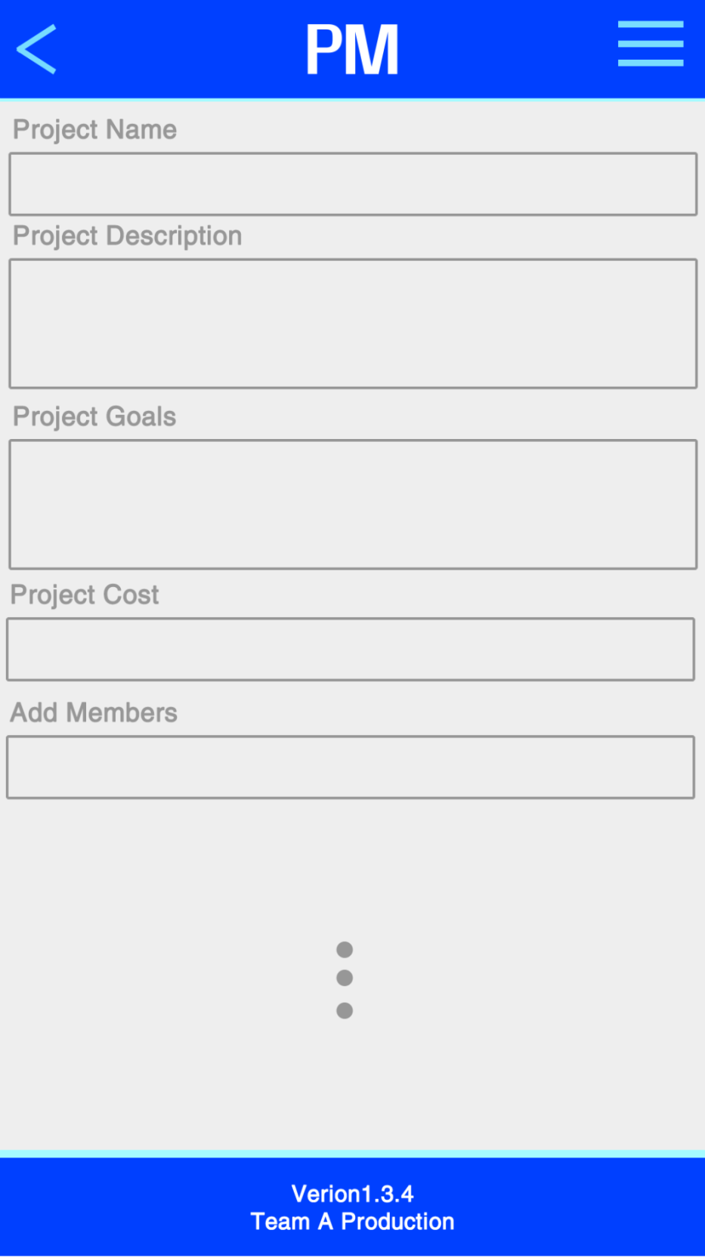

**3.8 Project Screen**

The project screen is an informative screen that provides a description of the project, its goal, cost and members that are part of the project. The leader or members can get to this screen by clicking the button “Project Description”, which is available in both, leader’s view screen and members’ view screen.

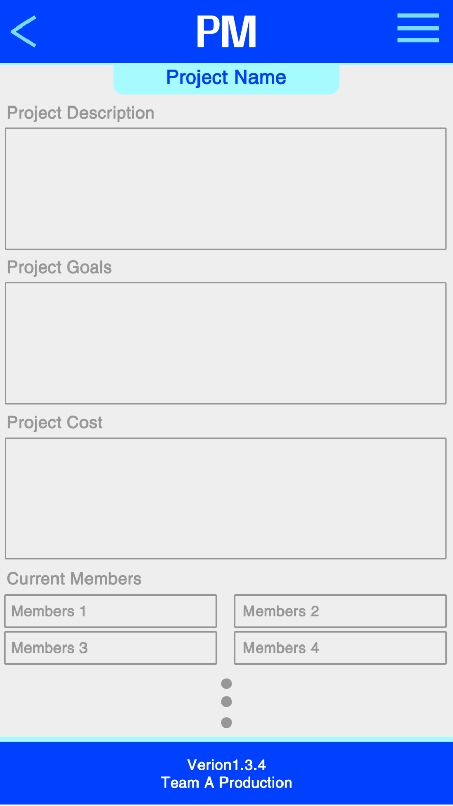

**3.9 Profile Screen**

The profile screen is where members can see the people currently working in the project. This screen display a member’s picture, name, username, position, his or her starting date, phone and email address. This screen can be accessed from three different screens, from the leader’s view screen, it can be accessed by clicking the “Members” button, from the Members’ view screen, it can be accessed by clicking the “Other” button and lastly, it can be accessed from the project screen which list all the members of a project. Clicking a member will take you to that member’s profile.

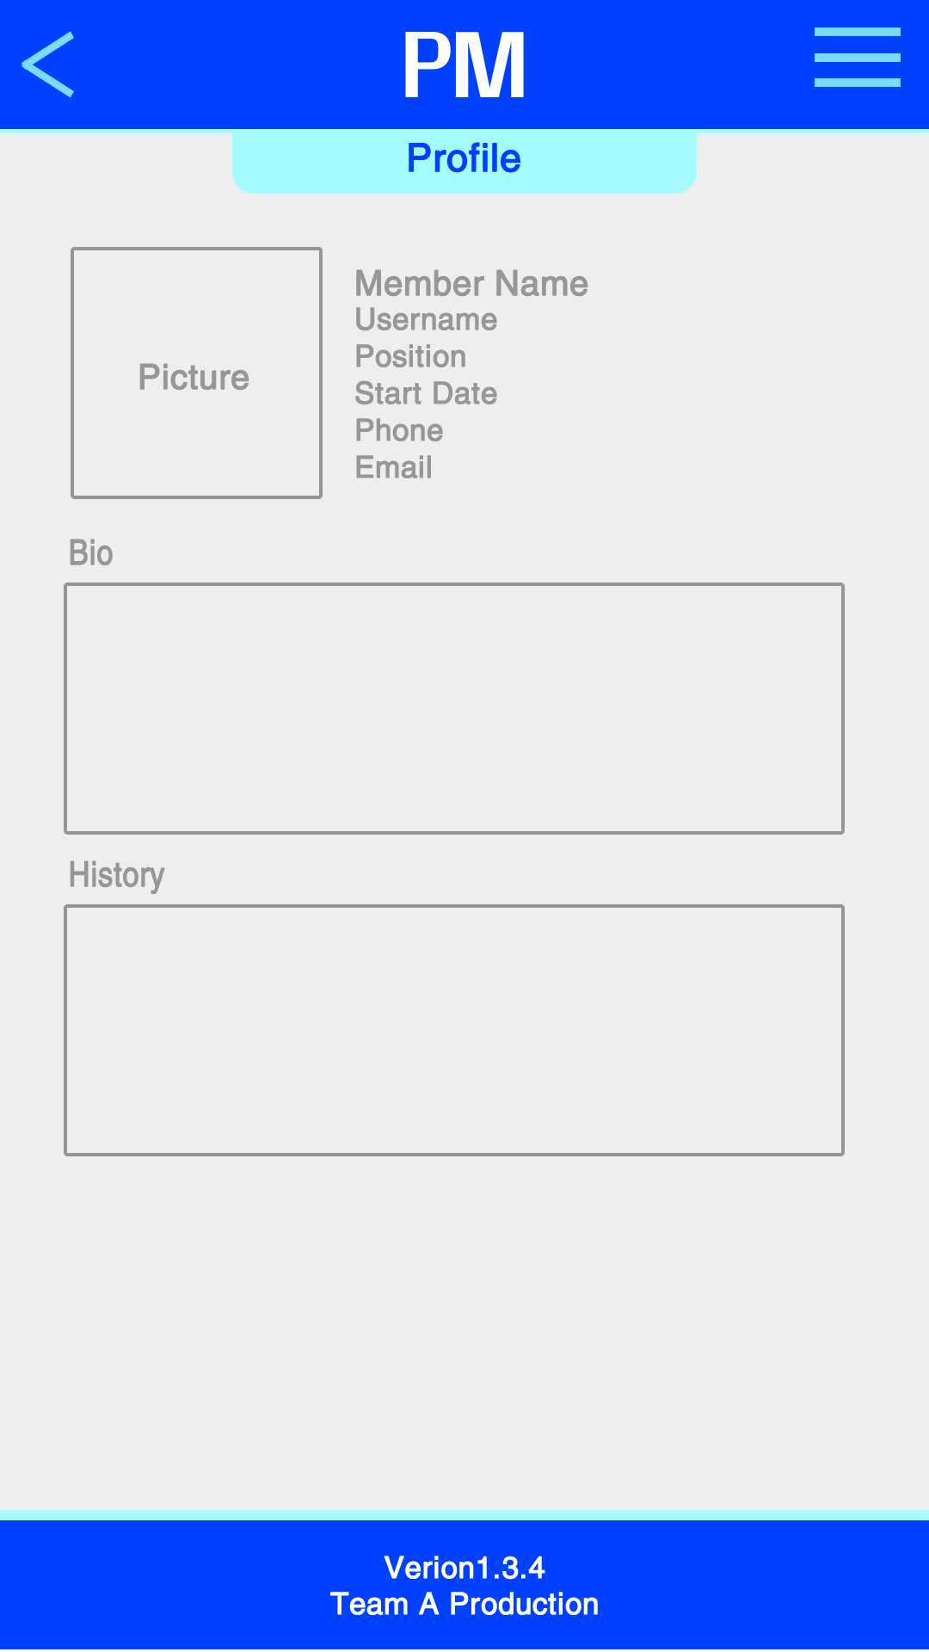

**3.10 Member’s View Screen**

The Member’s view screen is the most important screen to a member because from this screen, a member could check the assigned task progress, the task , access to messeging services, calendar, the project description and other services. This screen’s interface is composed of buttons that once clicked, takes you to a different screen.

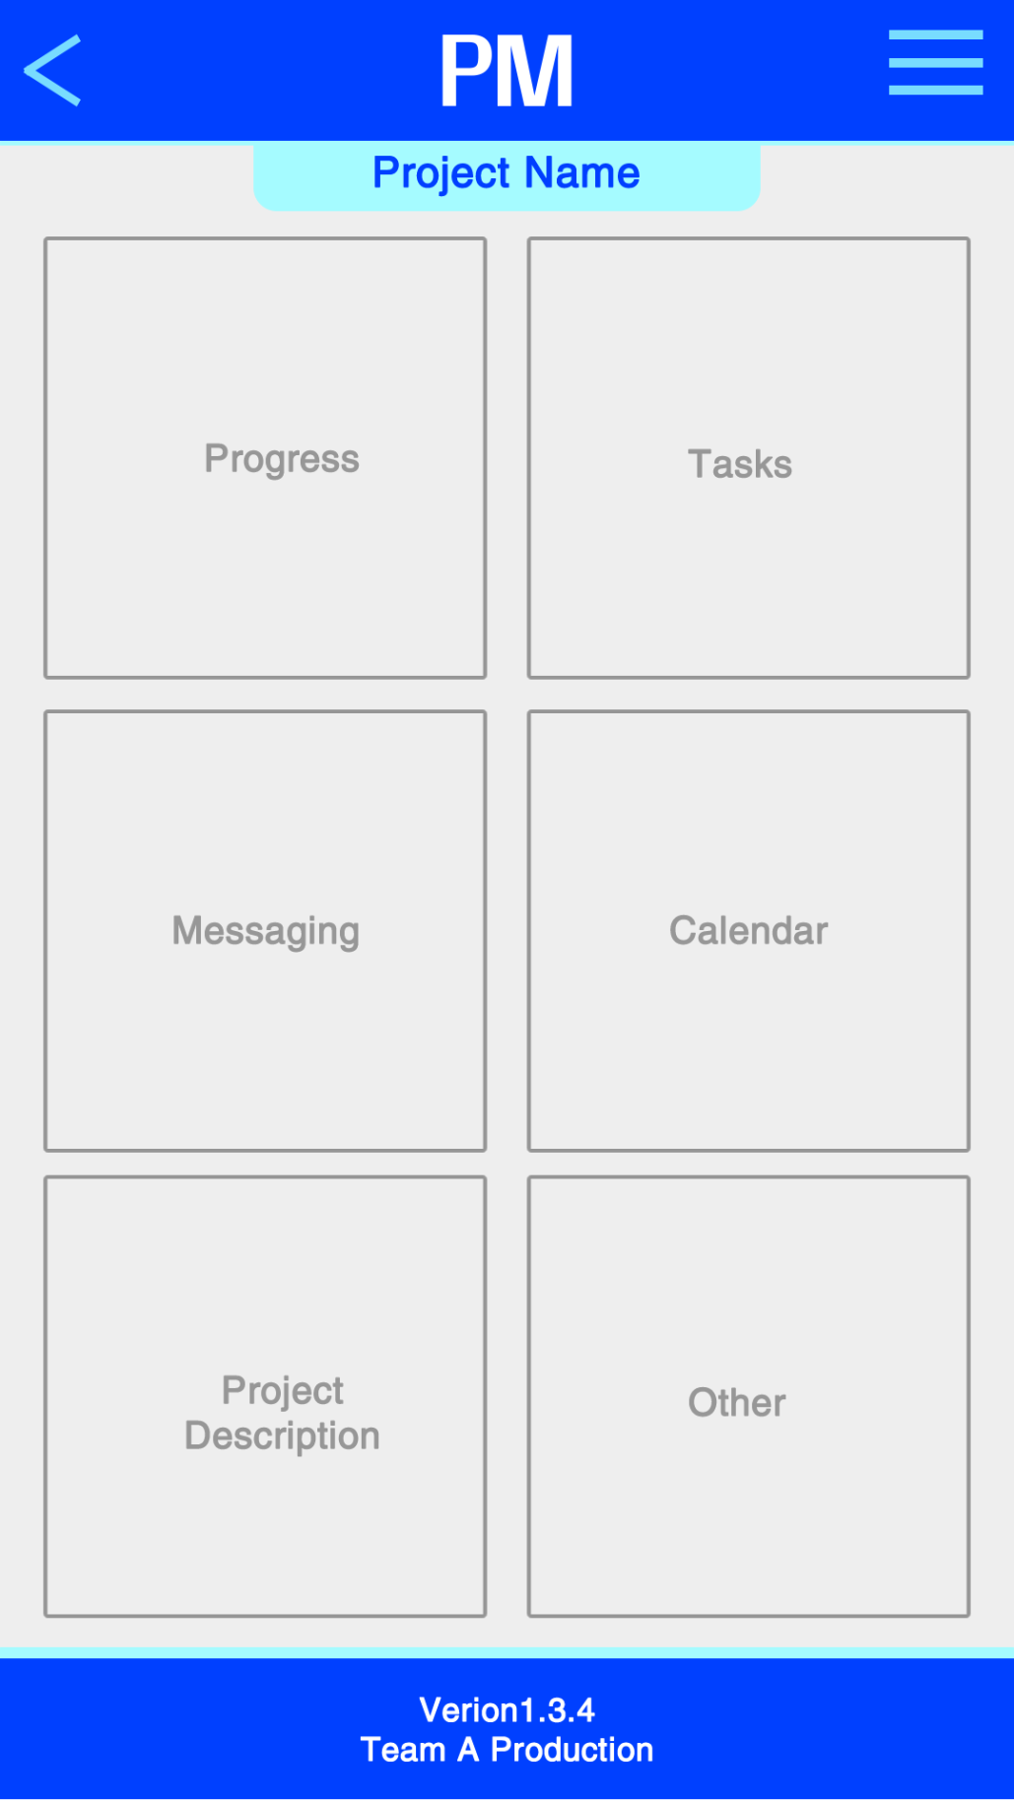

**3.11 Leader’s View Screen**

The leader view screen is very similar to the member’s view screen but with more added features and privilege. From this screen, the leader can see anything related to a project. The leader can as well, use the messaging interface provided by the app. He or she can see the calendar with all assigned tasks’ due dates, view a description of the project and each members who are currently working in the project. As the members’ view screen, the leader’s view screen’s interface is composed of buttons that once clicked, takes the leader to a screen associated with the clicked button.

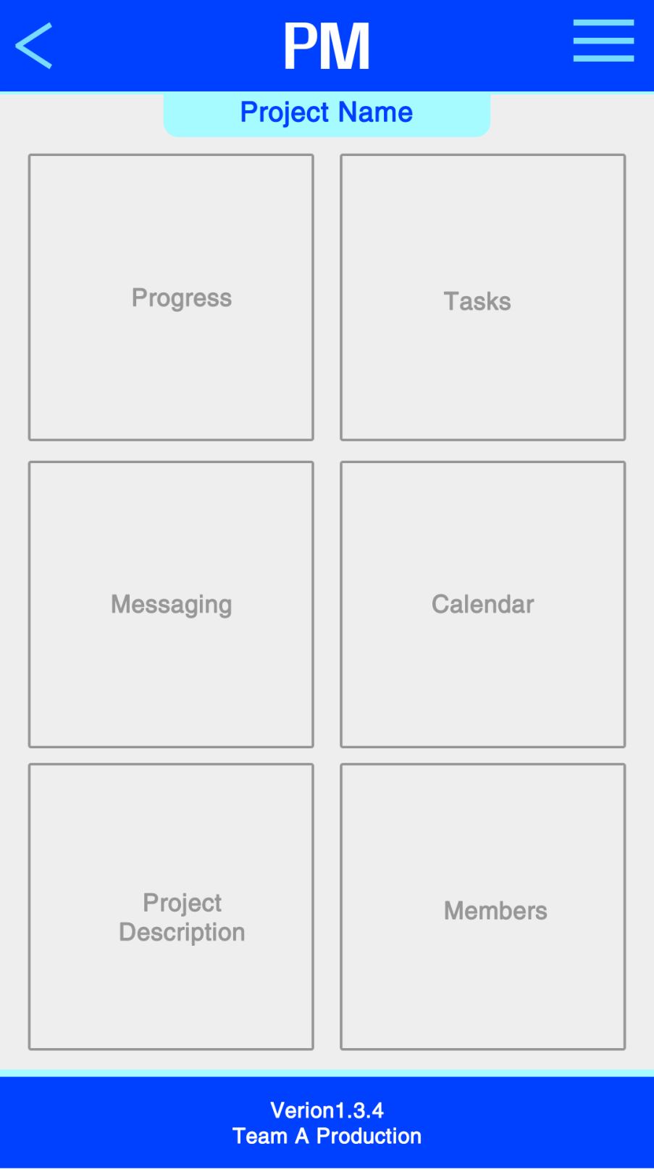

**3.12 Progress Screen**

The progress screen serves as a visual representation of the project’s progress and individual task progress. This screen is very useful because it reminds members of due dates of individual tasks and the project. This screen can be accessed through the members’ view screen or the leader’s view screen. Privilege will dictate what users can see or not see depending on their role in the project.

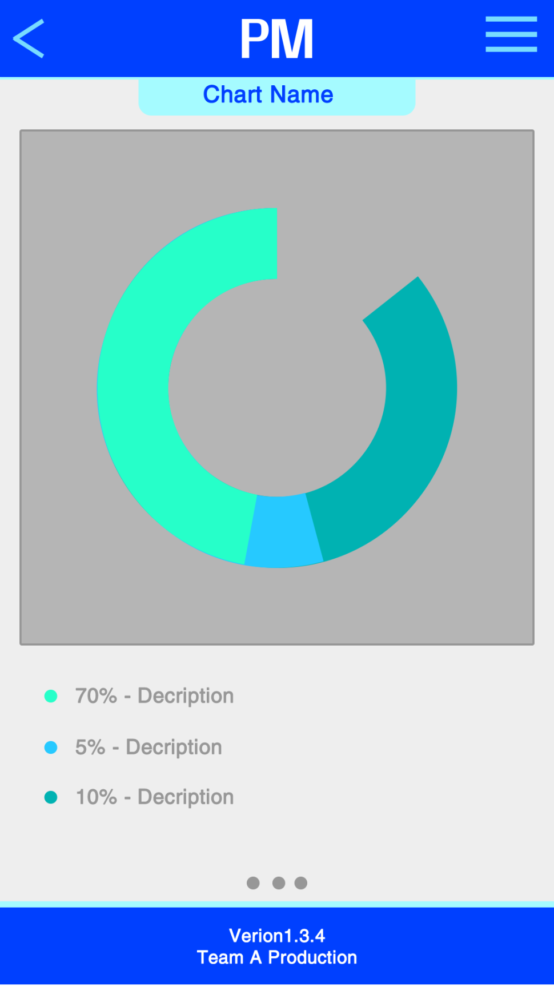

**3.13 Calendar Screen**

The calendar screen is very useful when used with the progress screen because the user can deduce if they are going to meet the deadline of the project or individual task. The calendar shows to the leader, the due dates of each task and the project and to the members the due dates of their tasks. The leader get to this screen from the leader’s view screen and the members form the member’s view screen.

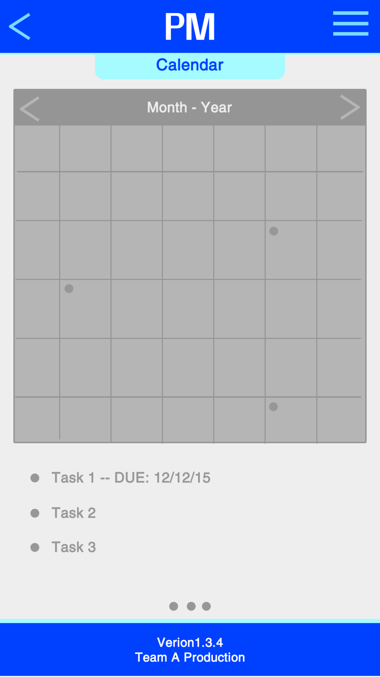

**3.14 Task List Screen**

The task list screen lists all the tasks of the current project. This screen is available to both, the leader and the members. This screen is accessed from the leader’s view screen and member’s view screen. Once again privilege will dictate what content is available to each role.

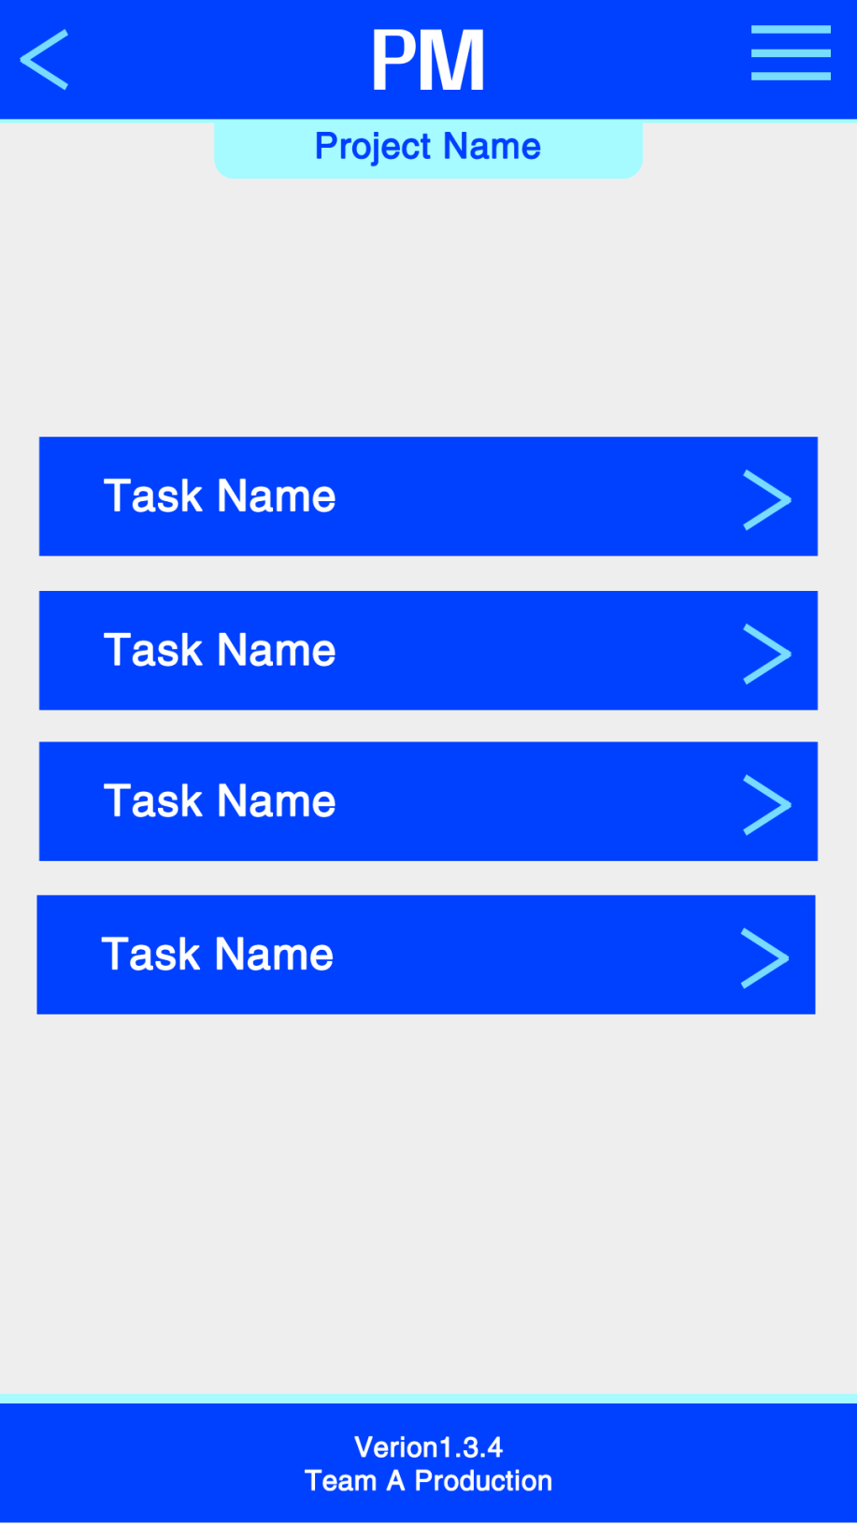

**3.15 Message Screen**

This screen is one of the most fun to use because of its synchronous communication interface. It is like text messaging the only different is that both users have to be members of the project to establish a communication session. Both users are able to upload documents to each other by clicking the paperclip button above the keyboard. The leader and the members get to this screen from their leader’s or member’s view screens.

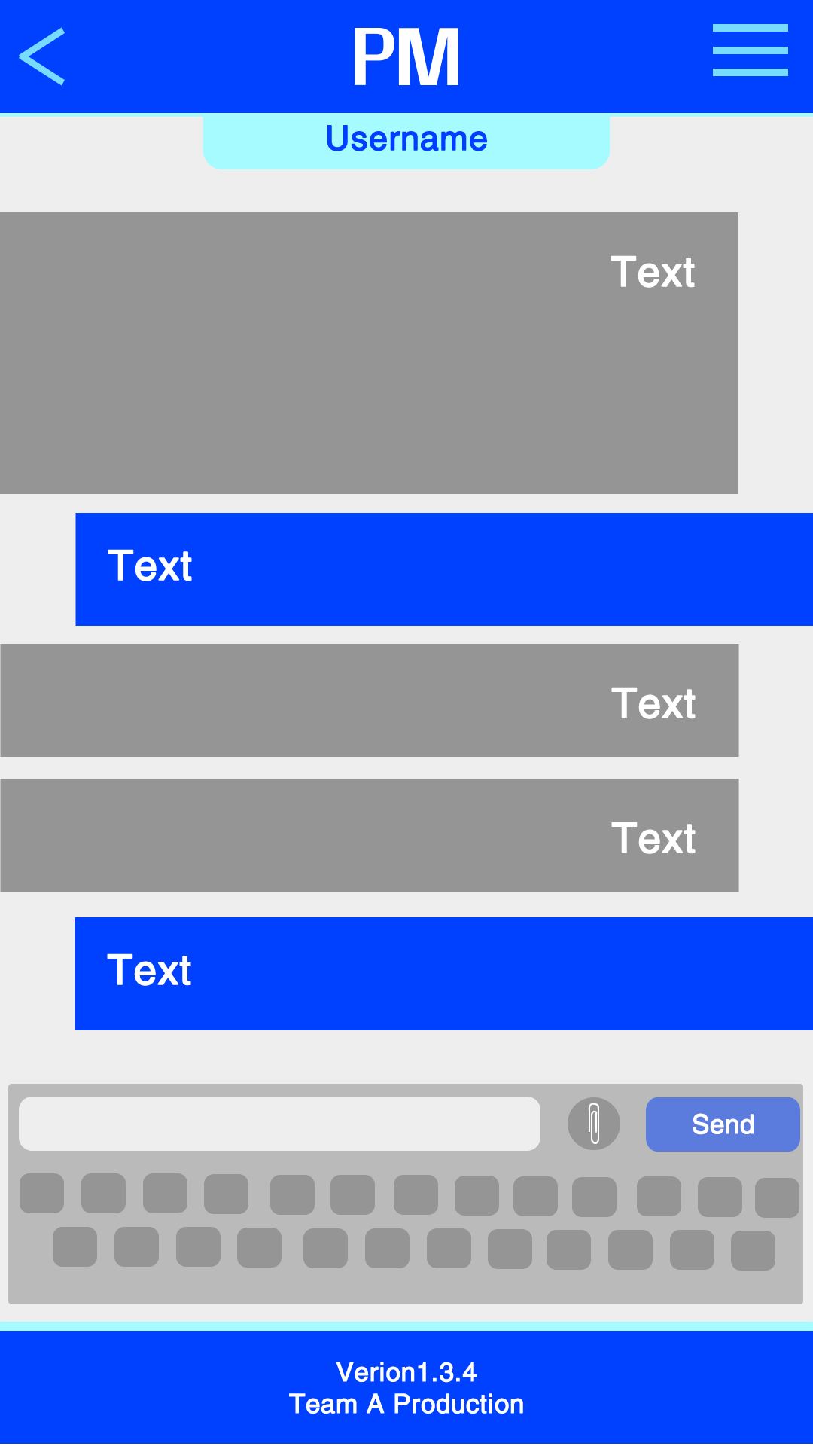

**3.16 Member List Screen**

This screen is only visible to the leader. The leader is able to see in a list format, all the members that are part of the current project.

